Example:
WAP to create array of size 10 and input the element and find its occurrence in total array
10 20 30 10 20 30 10 20 30 10
Enter the element for find occurrences 10
Total number of occurrences is 4
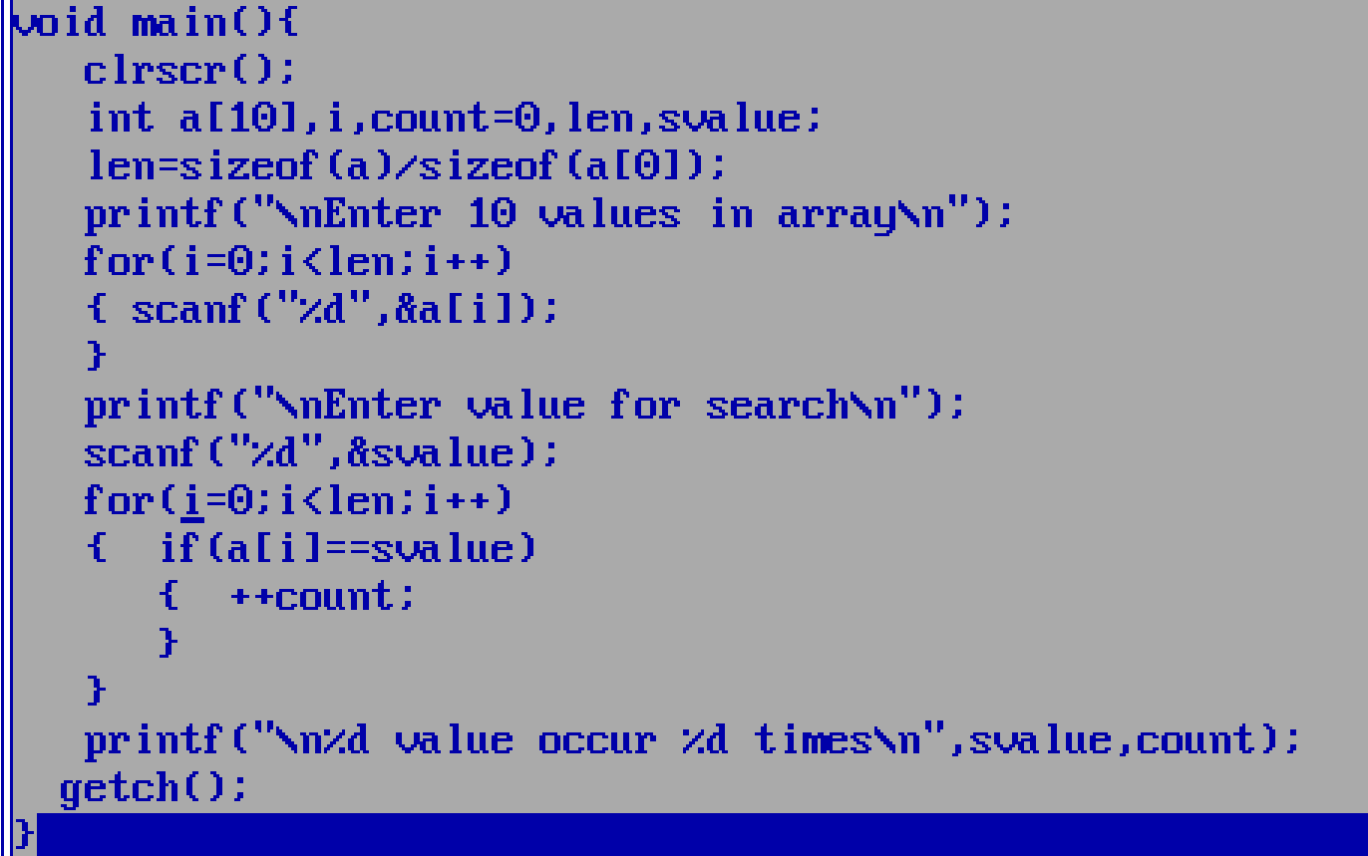
Example: WAP to create array of size 5 and reverse it.
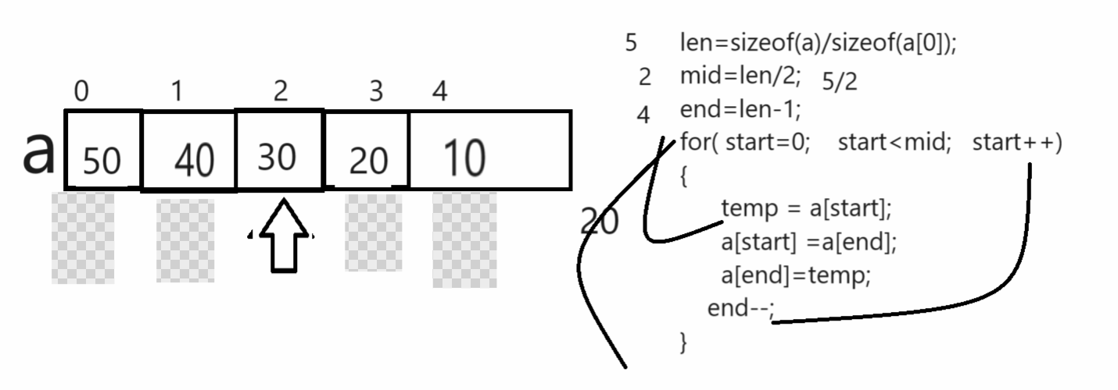
Example: with source code
#include<stdio.h>
#include<conio.h>
void main(){
clrscr();
int a[5],i,end,len,mid,temp;
len=sizeof(a)/sizeof(a[0]);
mid=len/2;
end=len-1;
printf("\nEnter 10 values in array\n");
for(i=0;i<len;i++)
{ scanf("%d",&a[i]);
}
printf("\nDisplay array before reverse \n");
for(i=0;i<len;i++)
{ printf("a[%d] ---->%d\n",i,a[i]);
}
for(int start=0;start<mid;start++)
{ temp=a[start];
a[start]=a[end];
a[end]=temp;
end--;
}
printf("\nDisplay array after reverse\n");
for(i=0;i<len;i++)
{ printf("a[%d] --->%d\n",i,a[i]);
}
getch();
}
Example: create array of size 6 and store 5 values in it and maintain one extra block and insert index and value and store value on specified index and shift values from that index to n-1
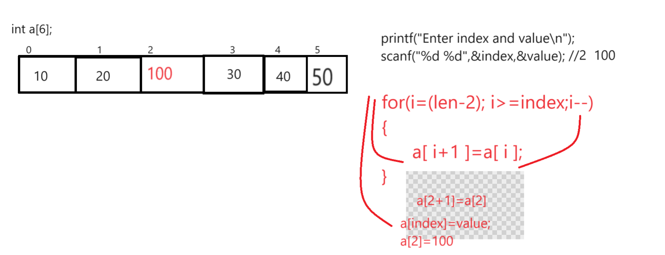
Example: Complete source code
#include<stdio.h>
#include<conio.h>

void main(){
int a[6],len,index,value,i;
clrscr();
len=sizeof(a)/sizeof(a[0]);
printf("\nEnter values in array\n");
for(i=0;i<(len-1);i++)
{ scanf("%d",&a[i]);
}
printf("\nDisplay array before insert value\n");
for(i=0; i<len; i++)
{ printf("a[%d] ---->%d\n",i,a[i]);
}
printf("\nEnter index and value\n");
scanf("%d %d",&index,&value);
//insertion logic
for(i=(len-2); i>=index;i--)
{ a[i+1]=a[i];
}
a[index]=value;
printf("\nDisplay array after insert value\n");
for(i=0;i<len;i++)
{ printf("a[%d] ----->%d\n",i,a[i]);
}
getch();
}

Example: WAP to input 5 values in ascending order and find the missing elements
1 4 8 9 11
Output: 2 3 5 6 7 10

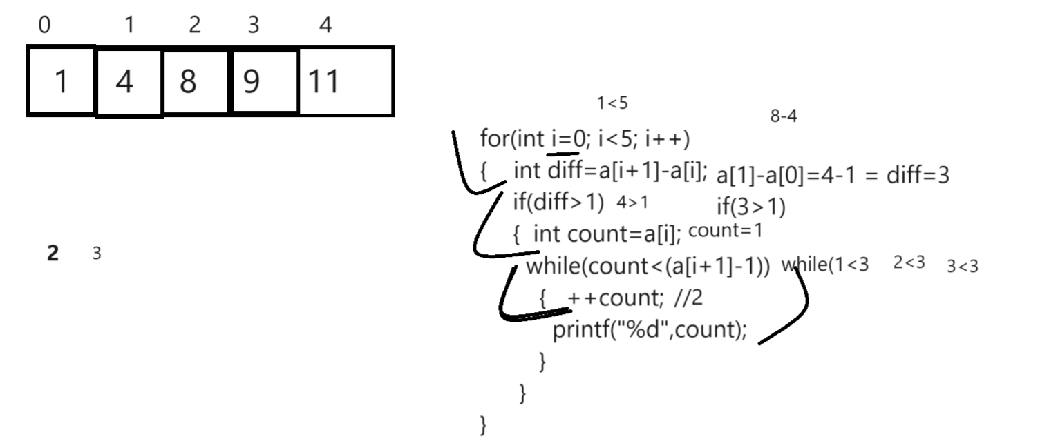
Complete source code
#include<stdio.h>
#include<conio.h>

void main(){
int a[5],i,len,diff,count;
clrscr();
len=sizeof(a)/sizeof(a[0]);
printf("\n\t\tEnter five values in array\n");
for(i=0;i<len;i++)
{ scanf("%d",&a[i]);
}
printf("\nDisplay array values\n");
for(i=0;i<len;i++)
{ printf("%d\t",a[i]);
}
printf("\nDisplay missing values\n");
for(i=0;i<len;i++)
{
diff=a[i+1]-a[i];
if(diff>1)
{
count=a[i];
while(count<(a[i+1]-1))
{
++count;
printf("%d\t",count);
}
}
}
getch();
}

Example: WAP to declare two array of size 5 and merge them in array and third array size is 10
#include<stdio.h>
#include<conio.h>

void main(){
int a[5],b[5],c[10],i,j,k;
clrscr();
printf("\nEnter five values in array\n");
for(i=0;i<5;i++)
{ scanf("%d",&a[i]);
}
printf("\nEnter five values in second array\n");
for(i=0;i<5;i++)
{ scanf("%d",&b[i]);
}
//merging logic
for(i=0,k=0;i<5;i++,k++)
{ c[i]=a[i];
}
for(i=0;i<5;i++,k++)
{ c[k]=b[i];
}
printf("\ndisplay first array\n");
for(i=0;i<5;i++)
{
printf("%d\t",a[i]);
}
printf("\nDisplay second array\n");
for(i=0;i<5;i++)
{ printf("%d\t",b[i]);
}
printf("\nDisplay array after merging\n");
for(i=0;i<10;i++)
{
printf("%d\t",c[i]);
}

getch();
}

